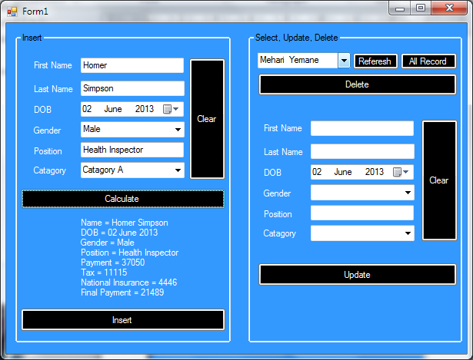**Onscreen help to assist the users of a computer program**

Refreshed the connection

Drop down menu to view the information on the database

Clear every txt boxes in the program

Employee information Entry

This where the text for the updates is going to be inserted

This button shows the information on the drop down menu

This button will updates everything that is in the txt boxes to the database.

This button will insert everything that is in the txt boxes to the database.

This is where all the entered information is viewed

This button calculate the payment using the category

Clear every txt boxes in the program